**SUMMARY:**

The input characteristics were measured for a Molex LTE antenna and a Molex WiFi antenna were mounted on Stycast. The minimum distance between the two antennas was 25 mm.

**MEASUREMENTS:**

The measurement setup is shown in the picture below. The measured input Reflection Coefficient for each antenna is shown on the next page.

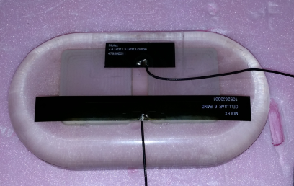

**Molex LTE antenna:**

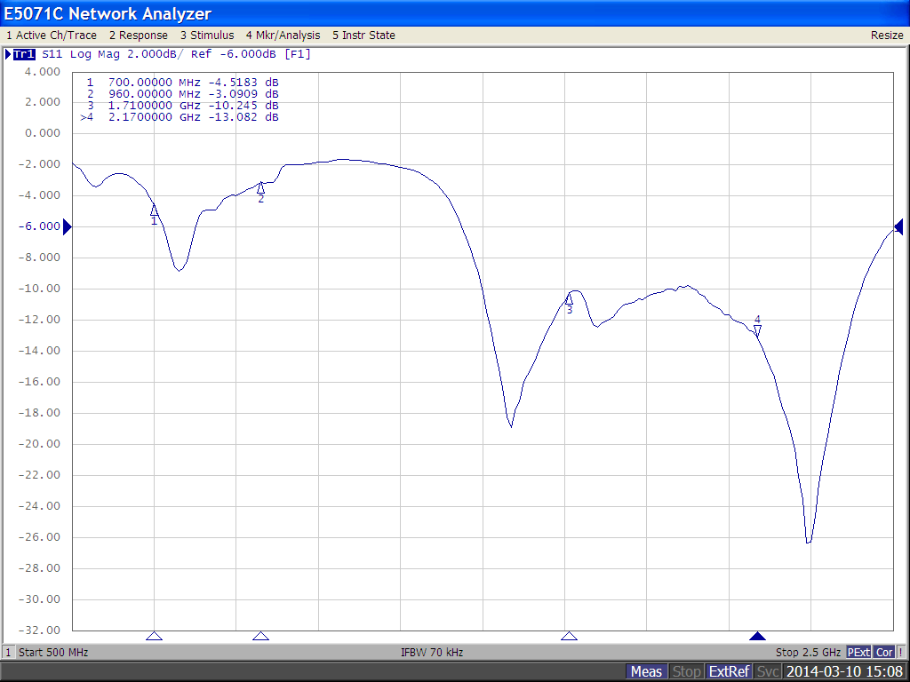

**Molex WiFi antenna:**

